How many potentially dangerous branches fall from mature eucalypts?
Citizen scientist instructions for measuring tree and branch characteristics
Why are we conducting this study?
Mature eucalypt trees provide a range of habitat features for native wildlife, as well as bringing natural beauty to urban landscapes. A PhD candidate at the ANU Fenner School is conducting research to find ways that will reduce the risk mature eucalypts pose to people and infrastructure in urban environments. One part of this study will calculate how many potentially dangerous branches are dropped by mature eucalypts over the period of a year. We will combine this information with data on pedestrian traffic in different parts of the urban environment to estimate the risk posed by mature eucalypts in different locations. To gather as much data as possible from across the east coast of Australia, we are asking for your help as a citizen scientist.
The goal for citizen scientists is to take measurements of every branch (of circumference greater than 8cm) dropped by their chosen trees over the period of up to one year. Branches that are this size or larger can pose a risk to people. For this study, we are including trees from the Eucalyptus, Angophora, Corymbia and Lophostemon genera.
Equipment needed
- Charged mobile phone with camera capacity
- 4m tape measure (or ~4m of string and a ruler)
- Printed data sheet or paper to write on
- Pencil or pen
- A roll of coloured PVC or electrical tape (that will stick to bark and last in the weather)
Measuring the tree characteristics at each site
Step 1. Find a suitable tree. For this study, we are seeking:
- Mature eucalypts of a circumference greater than 160cm (measured at breast height or approximately 1.3m above the ground).
- Trees in areas where branches that fall from the tree are unlikely to be removed (e.g. nature reserves, ex-farmland sites, your own private property).
Be sure to only measure trees on days when there is not much wind.
Step 2. Record the following characteristics of the tree. This information only needs to be recorded on the first visit to the tree.
Tree Characteristic | How it is measured
GPS location | Using a handheld GPS unit or an app on your mobile phone (such as Google Maps), record the precise latitude and longitude coordinates of the tree in decimal degrees to 6 decimal places (e.g. -37.275176, 149.118250). For help using the Google Maps app, visit https://support.google.com/maps/answer/18539?co=GENIE.Platform%3DiOS&hl=en&oco=0.
Tree species | Identify eucalypt species by their bark, fruit and leaves. Take photos of these characteristics as well as a photo of the full tree showing its canopy and email them to cara.parsons@anu.edu.au.
Circumference of trunk (cm) | Record the circumference of the trunk at breast height (approximately 1.3m above the ground).
Evidence of pruning | Record ‘yes’ if there is evidence that the tree has had branches removed by a chainsaw.
Evidence of hollows | Record ‘yes’ if you can see any hollows in the tree’s trunk or limbs.
Once you have recorded the tree characteristics, any dropped limbs of circumference greater than 8cm will need to be marked (see figure 1) or cleared well away from under the canopy of the tree.
Measuring fallen branches at each tree
Step 3. Each tree can be revisited as often as you like to check for fallen branches over the period of up to one year. Any branch of circumference greater than 8cm will need to have the following information recorded:
Branch Characteristic | How it is measured
Living / Dead | Was the branch living when it fell from the tree? Live branches would have tearing at attachment point showing signs of living wood and/or sap, and leaves/fruits attached.
Branch circumference (cm) | Measure the circumference of all fallen branches at the largest end (see figure 1).
Branch length (m) | Use a measuring tape, or pace beside the branch, to estimate the length of each branch to the nearest metre. Only measure the main branch piece; don’t include the length of any twigs or smaller parts branching off.
Distance to branch end (m) | Starting at the tree trunk, measure the distance to the furthest point of the dropped branch to the nearest metre using a measuring tape, or by pacing.
Once a branch has had its information recorded, then mark with electrical tape or spray paint or move well away from under the canopy.
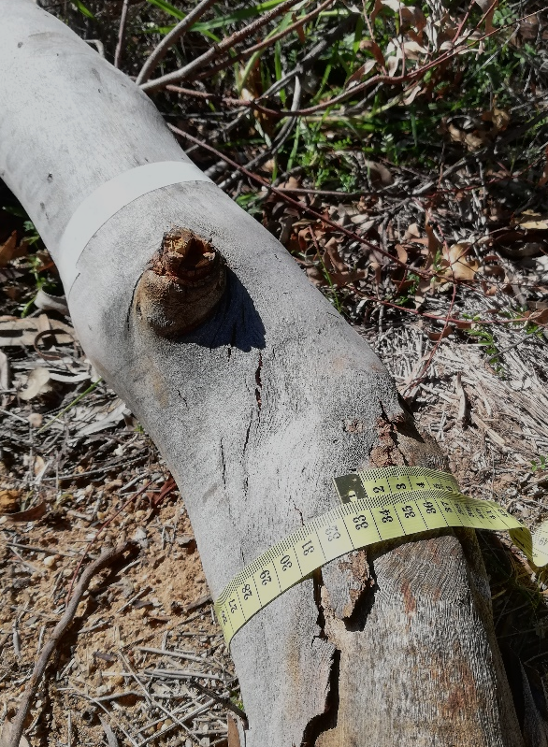
Figure 1. Tape measuring the circumference of the fallen branch at its thickest point.
Also note the white electrical tape used to mark the branch after it has been measured.

